C A R D I O P U L M O N A RY

CENTRIFUGAL PUMP SYSTEM

USER’S MANUAL

1. General
The Jostra RotaFlow System is a centrifugal pump that is intended to be
used in an extracorporal perfusion circuit to pump blood during
cardiopulmonary bypass procedures, as a stand-alone unit or on a Jostra
Heart Lung Machine console.

Some features of the RotaFlow System
The flow can be kept constant, independent of the pressure.

Air bubbles in the circuit can be detected and prevented from entering
the patient.
The system can run at least 1.5 hours on the battery backup under normal
conditions.

Further features on a Jostra Heart Lung Machine
The pressure can be monitored and regulated.

Most functions needed during an operation can be controlled from the
system control panel.
Useful signals and data are displayed.

A complete perfusion protocol can be recorded on-line or off-line with
JOCAP XL for later analysis and print-out.

1.1 Maintenance and repair
Pull away the ventilation slot collar of the RotaFlow Drive Unit and
clean the ventilation holes regularly.

Service and repair should be performed by Jostra authorised personnel
only.

Service the machine every 500 hours of operation or at least every
6 months.
Generally a normal household washing-up liquid can be used to clean the
front panel foils. If there is any doubt what to use, check with a Jostra
representative.

Do not use chemical solvents (such as alcohol, ether and acetone) and
do not spill anaesthetics (such as Foram (Isofluoran)) as this could
damage the machine.
NOTE Before use read the User Manual thoroughly!

CAUTION

Switch off the main switch before maintenance, cleaning, preparation
for operation, storage or replacements.

Do not touch the plugs of the RotaFlow Console as static electricity
and dampness could cause damage.

WARNING
Do not use the RotaFlow System for suction.

Never use the RotaFlow System without a valve or other satisfactory
systems and methods to prevent reverse flow.

Never let a diathermy knife touch the measuring system or the tubing
as this could affect the flow display.
WARNING First deactivate the flow regulation (see “4.3 Flow regulation”).

Clamp the tube and immediately reduce the speed to zero, to avoid
haemolysis.

Simultaneously increase the speed when opening the clamp. Never
open the clamp at high speed, to avoid magnetic uncoupling.

Magnetic uncoupling
WARNING Magnetic uncoupling is indicated by dropping flow (and a whirring
noise).

If magnetic uncoupling occurs, immediately deactivate flow
regulation (see “4.3 Flow regulation) and clamp the tube, to prevent
reverse flow. Reduce the speed to zero. When the RotaFlow

Centrifugal Pump has come to a standstill, simultaneously increase
the speed when opening the clamp.
If magnetic uncoupling persists, use the RotaFlow Emergency Unit.
If it still persists, use a spare RotaFlow Centrifugal Pump.

1.3.5 Membrane oxygenator
Pressure fluctuations (caused by an abrupt fall in the arterial flow) in a
microporous membrane oxygenator can cause gas microemboli (if the
blood pressure gets lower than the gas pressure).

WARNING

The pressure in the arterial tubing must be monitored and the pump
adjusted so that the pressure in the blood flow through the
oxygenator is always higher than the gas pressure.

2.1 RotaFlow Console

2.1.1 Front panel
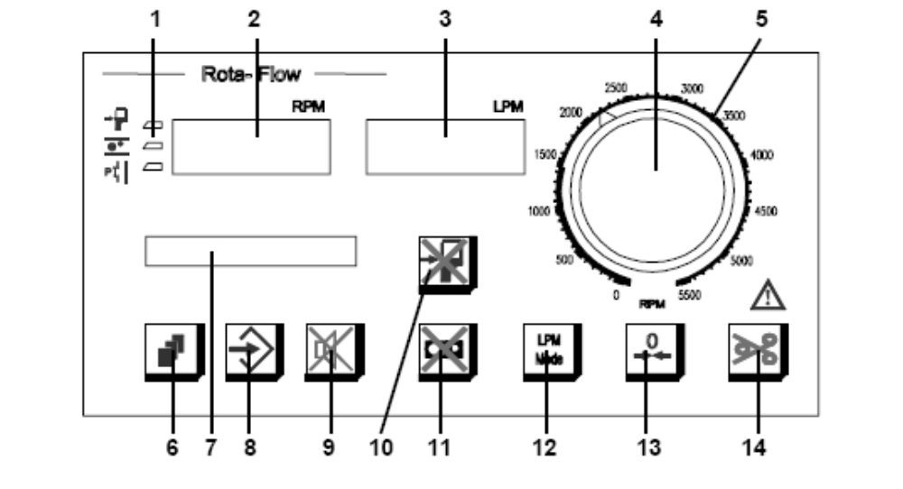
1. Intervention LEDs
See “5.3.1 On a Jostra Heart Lung Machine console”.
2. Speed display (RPM = revolutions per minute)
3. Flow display (LPM = litres per minute)
4. Flow adjustment knob
Pull and turn to change the flow (a no-pull knob is optional).
5. Speed scale (if the speed display stops working)
6. Select button
7. Status display
8. Set button
9. Audio off button
Flashes when the present acoustic alarm is switched off. The acoustic alarm returns
with every new alarm condition.
10. Level override button
Press for three seconds to switch off the stand-alone level intervention. The button
flashes. Press again to switch on the level intervention. See “4.5 Level”.
11. Bubble override button
Press to reset the bubble detector after a pump stop (and before start in “STAND
AL” mode). Press for three seconds to switch off the stand-alone bubble
intervention. The button flashes. Press again to switch on the bubble intervention.
See “4.4 Air bubbles”.
12. LPM Mode button
See “4.3 Flow regulation”.
13. Zero adjustment button
Press for three seconds to calibrate the flow measuring to zero (while the actual
flow is within ±1 LPM).
14. Clamp button
Press to confirm that there is a valve or other satisfactory systems and methods to
prevent reverse flow at the display message “VALVE?” when switching on. (For
future use: Lit when the clamp is open. Press to close the clamp. Press for three
seconds to open the clamp again.)

2.1.2 Front view
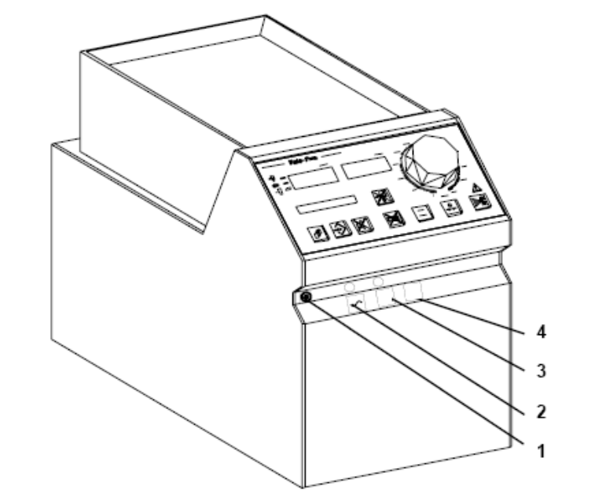
1. On/off switch
2. External voltage light
Lit when an external voltage is available.
3. Battery operation light
Lit during internal battery operation. See “5.5 Battery operation”.
4. Battery charging light
Lit when the batteries are being charged.

WARNING
Switch off the on/off switch when not using the RotaFlow Console.
Breaking the external voltage only activates battery operation.

2.1.3 Rear view
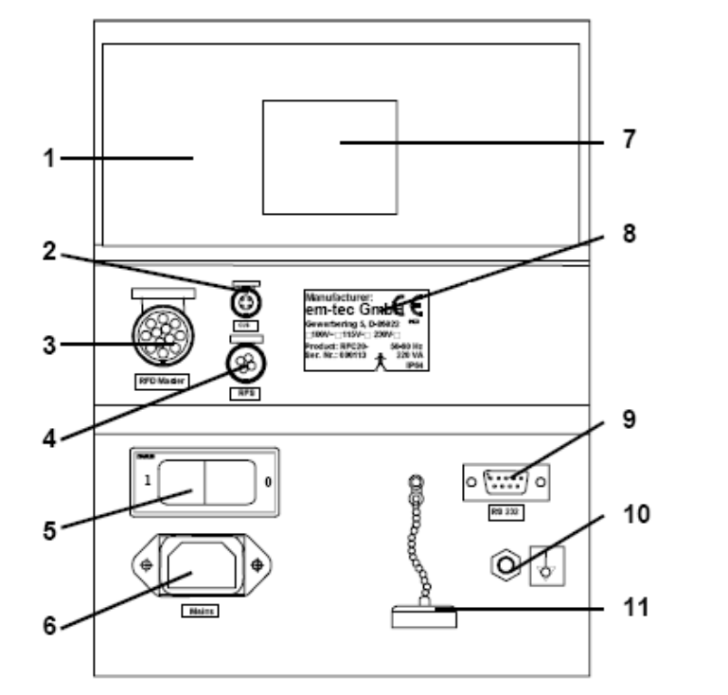
1. Battery pack cover
2. Level sensor socket (“CLS”)
3. Socket for master RotaFlow Drive Unit (“RFD Master”)
4. For future use: Automatic clamp socket
5. Mains circuit-breaker (This must be “on” if pump is used as a stand alone. Otherwise, it will run off battery, and then will stop when battery is drained!)
6. Mains socket
7. RotaFlow Drive Unit holder
8. Label
9. RS232 socket
10. Connection for potential equalization
11. Cover for RS232 socket

3. Preparation for operation

3.1.1 On a Jostra Heart Lung Machine console

CAUTION

Switch off the pump switch on the Jostra Heart Lung Machine
console before installing or removing a RotaFlow Console.

Installation

1. Switch off the pump switch and open the socket cover on the Jostra

Heart Lung Machine console.

2. Open the plug cover on the RotaFlow Console.

3. Put the RotaFlow Console carefully in place. It is immediately ready
for operation.

Removal

1. Switch off the pump switch on the Jostra Heart Lung Machine
console and the on/off switch on the RotaFlow Console.

2. Lift off the RotaFlow Console and make sure that the plug cover is
closed.

3. Put on the socket cover on the Jostra Heart Lung Machine console.

3.1.2 In stand-alone operation
See “2.1.3 Rear view”.
1. Connect the mains cable to the mains socket.

WARNING

In stand-alone operation the mains circuit-breaker must be on, to
avoid battery operation.

3.2 Attachment of the RotaFlow Drive Unit
1. Attach the RotaFlow Drive Unit with the butterfly screw to a stable
mast with a diameter between 25 mm and 40 mm (on a Jostra Heart
Lung Machine) or to the RotaFlow Drive Unit holder on the
RotaFlow Console.
2. Switch off the RotaFlow Console.
3. Connect the master RotaFlow Drive Unit cable to the “RFD Master”
socket.

CAUTION

Switch off the RotaFlow Console before connecting or disconnecting
the RotaFlow Drive Unit cable.

3.2.1 Operating position on a Heart Lung Machine

3.2.2 Stand-alone operating position
NOTE Attach the RotaFlow Drive Unit to a stable mast with a diameter
between 25 mm and 40 mm or to the RotaFlow Console in a position
above it for the stability.

3.3 Connection of the tube
WARNING: Connect 3/8" × 3/32" PVC or silicone tubes.
Tubes with thinner walls could collapse.

Only use ultrasonic grease intended for the flow meter and bubble
sensor.

1. Switch off the RotaFlow Console.
Connect firmly the inlet tube to the middle
inlet and the outlet tube to the side outlet of
the RotaFlow Centrifugal Pump.

2. Apply a strip of ultrasonic grease along the bottom of the outlet
for the flow meter and bubble sensor.

3. Insert the RotaFlow Centrifugal Pump
into the RotaFlow Drive Unit.

4. Close the lock.
3.4 Priming and zero calibration

CAUTION

Prime before use to prevent the RotaFlow Centrifugal Pump bearings
to be damaged.

1. Prime with an isotonic electrolyte or a saline solution, according to
the RotaFlow Centrifugal Pump manual.

2. Clamp the tube beyond the RotaFlow Centrifugal Pump and turn the
flow adjustment knob to zero.

3. When the RotaFlow Centrifugal Pump has come to a standstill, press
the “Zero adjustment” button for three seconds to calibrate the flow
measuring to zero.

4. Operation
WARNING Always have a RotaFlow Emergency Drive easily accessible and
ready for use.

Set the patient specific lower flow limit (“SET FLIM”) correctly, see
“4.2 Selection of settings”. Too low flow can be dangerous and harm
the patient.

4.1 Modes of operation
The RotaFlow System must have a name describing its mode of
operation. To select the mode of operation, see “4.2 Selection of
settings”. See also “5.3 Intervention”.
NOTE For use on a Jostra Heart Lung Machine console, see also the Jostra
Heart Lung Machine manual.
Name in the “SET MODE” menu
Name in the status display during operation

ART ART

Arterial pump for continuous pumping with interventions through the
Jostra Heart Lung Machine.

ART-PULS A-P
Arterial pump with a pulsatile pumping option with interventions through
the Jostra Heart Lung Machine.

STAND AL SA

Stand-alone pump with interventions through the internal bubble sensor
and a level sensor connected to the RotaFlow Console. Press the “Bubble
override” button to reset the bubble detector before start.

FREE FRE
Pump without interventions (and detached from communication with the
Jostra Heart Lung Machine).
Example: An error in the monitoring system might stop the RotaFlow
System (except in “FREE” mode). Assign the RotaFlow System as
“FREE” to continue operation.
NOTE Do not use “FREE” mode during an operation, except in an
emergency.

4.2 Selection of settings
1. Press the “Select” button repeatedly until the status display shows
what you want to change of the following.
2. Press the “Set” button.

“SET MODE” – Mode of operation
3. Press the “Select” button to choose the desired mode of
operation.

“SET BRIG” – Display brightness
3. Press the “Select” button to choose between 25 %, 50 % and
100 % brightness.

“SET FLIM” – Lower flow limit
3. Press the “Select” button to choose between off, 0.1–0.9 LPM
in steps of 0.1 and 1.0–5.0 LPM in steps of 0.5.

“SET LLIM” – Lower speed limit
3. Press the “Select” button to choose between off and 500–
4500 RPM in steps of 500.

“SET HLIM” – Upper speed limit
3. Press the “Select” button to choose between off and 3000–
5000 RPM in steps of 500.

“SET CLAM” – Automatic or manual clamp
For future use.

“SET BTMP” – Blood temperature
3. Press the “Select” button to choose between 15°C–40°C in
steps of 5°C (to optimize the flow measuring).

“SET S-AL” – Soft alarm

See the Jostra Heart Lung Machine manual
3. Press the “Select” button to choose between soft alarm on and
soft alarm off.
4. Press the “Set” button for three seconds (press any other button to
leave the selection of settings without memorizing the change). An
acoustic signal sounds and the status display shows the mode of
operation.
NOTE If “FLIM”, “LLIM” or “HLIM” is exceeded, the acoustic alarm
sounds and an error message flashes, see “5.8 Error messages”.

4.3 Flow regulation
1. Set a flow above 0.5 LPM.
2. Press the “LPM Mode” button for three seconds to enter flow
regulation. The current flow is allocated to the current speed scale
position.
3. Adjust the flow (instead of the speed) by turning the flow adjustment
knob.
Press the “LPM Mode” button again to return to speed regulation.

5. Safety
The RotaFlow System switches to a safe state, a stop (as this could be
managed through manual operation), at defects which could lead to
faulty operation of the RotaFlow System.

The RotaFlow System is continuously monitored during operation. If an
error is found, the RotaFlow System stops, the acoustic alarm sounds and
a display message is shown (see “5.8 Error messages”).
WARNING In an emergency or at a stop, close the arterial and the venous clamps
(to prevent reverse flow) until the pumping is safe again.

5.1 Messages when switching on
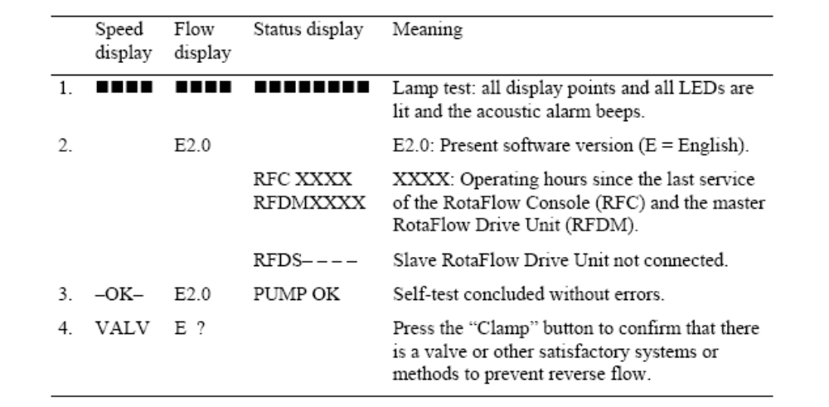

5.2 Before operation
• Check that the RotaFlow System functions.
• Check that the correct mode of operation is assigned for the
RotaFlow Console.
• Check that the speed display corresponds to the speed scale at the
flow adjustment knob.
• Check every chosen intervention by simulating an alarm condition.

5.3 Intervention
NOTE In “FREE” mode the RotaFlow System cannot be influenced by
external signals, e.g. the monitoring system.

5.3.1 On a Jostra Heart Lung Machine console
The RotaFlow System can be set not to exceed a pressure limit or to stop
at the detection of air bubbles in a tubing (in “ART” and “ART-PULS” mode), via the monitoring system of the Jostra Heart Lung Machine. See the Jostra Heart Lung Machine
manual.
The chosen intervention is shown by the intervention LEDs.
NOTE If the intervention is switched off, or at an error, the corresponding
LED starts to flash. Switch off the RotaFlow Console for a few
seconds to cancel the flashing.
The status display shows if an intervention has stopped the RotaFlow
System:
STOP PRx Stopped by the monitoring of pressure x (x = 1 to 4).
STOP LEV Stopped by the level monitoring.
STOP BUB Stopped by the air bubble monitoring.

5.3.2 In stand-alone operation
The RotaFlow System can be set to stop at the detection of air bubbles in
the tubing (in “STAND AL” mode).
The status display shows if an intervention has stopped the RotaFlow
System:
STOP LEV Stopped by the level monitoring (connected level sensor).
STOP BUB Stopped by the air bubble monitoring (internal).

5.4 Monitoring error on a Heart Lung Machine
The RotaFlow System stops (except in “FREE” and “STAND AL”
mode) if the monitoring system is switched off on a Jostra Heart Lung
Machine. An acoustic alarm sounds and the status display flashes “NO
COMM.”. The intervention LED flashes on a RotaFlow System with a
chosen intervention.
To continue operation, the RotaFlow System can be assigned as “FREE”
as described in “4.1 Modes of operation” and “4.2 Selection of settings”.
Here is a simpler method:
1. Turn the flow adjustment knob to zero (the acoustic alarm is switched
off).
2. The status display flashes “SET FREE”. Press the “Set” button to
switch the RotaFlow System to “FREE” mode.
3. Turn the flow adjustment knob to the desired flow.
WARNING A RotaFlow System that has been switched to “FREE” remain as
“FREE” when the monitoring system is switched on again.
Intervention of the monitoring system does not work in “FREE”
mode.

5.5 Battery operation

WARNING

Let Jostra authorized personnel replace the batteries every two years
or when they can no longer be fully charged within 8.5 hours or
when fully charged batteries cannot run the system longer than 30
minutes. Check the battery capacity at least every six months.
Proper disposal of the batteries are ensured by handing them back to
Jostra.
The RotaFlow System automatically switches to battery operation when
the external power supply (mains voltage or Jostra Heart Lung Machine
console) is interrupted. If power returns the RotaFlow System
automatically switches back to the external power supply.
The batteries are automatically charged when the RotaFlow System is
connected to the external power supply.

Battery voltage during battery operation
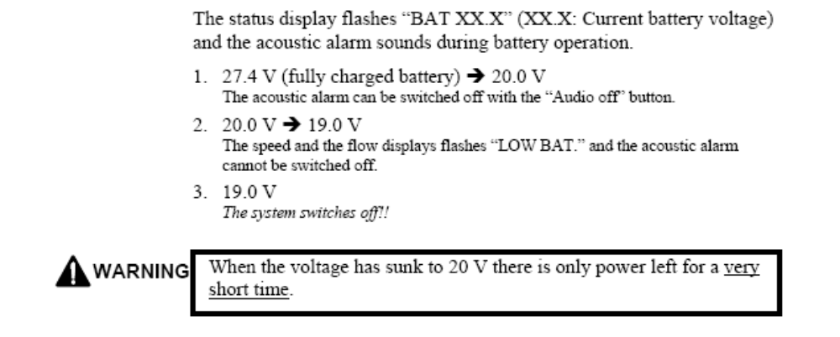

5.6 Separation from a Heart Lung Machine
during operation
This can be used in an emergency:
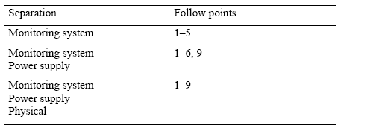
2. Assign the RotaFlow System as “STAND AL” as described in
“4.1 Modes of operation” and “4.2 Selection of settings”. The
RotaFlow System might stop.
3. Press the “Bubble override” button to reset the bubble detector
(shortly not to override the function).
4. If no level sensor is connected, press the “Level override” button for
three seconds. The button flashes.
5. The RotaFlow System starts again.
6. Switch off the pump switch on the Jostra Heart Lung Machine
console. The RotaFlow System automatically switches to battery
operation.
7. Lift off the RotaFlow Console and make sure that the plug cover is
closed.
8. Put on the socket cover on the Jostra Heart Lung Machine console.
9. Connect the mains cable and switch on the mains circuit-breaker on
the rear side of the RotaFlow Console.
NOTE In “STAND AL” mode, interventions work through the internal
bubble sensor and a level sensor connected to the RotaFlow Console.

5.7 Manual operation
A RotaFlow System is easily replaced with a spare RotaFlow System. In
an emergency, operation can be continued manually with a RotaFlow
Emergency Drive.
1. Close the arterial and the venous clamps.
2. Attach the RotaFlow Emergency Drive to a stable mast with the
butterfly screw.
3. Remove the RotaFlow Centrifugal Pump from the RotaFlow Drive
Unit. Insert it into the RotaFlow Emergency Drive.
4. Raise the handle and turn clockwise. The speed LEDs show the speed
from 1500 RPM to 5000 RPM in steps of 500 RPM (above
5000 RPM, all LEDs are lit).
5. When the speed is high enough, open both clamps.
NOTE Turning counter-clockwise is not possible.

5.8 Error messages
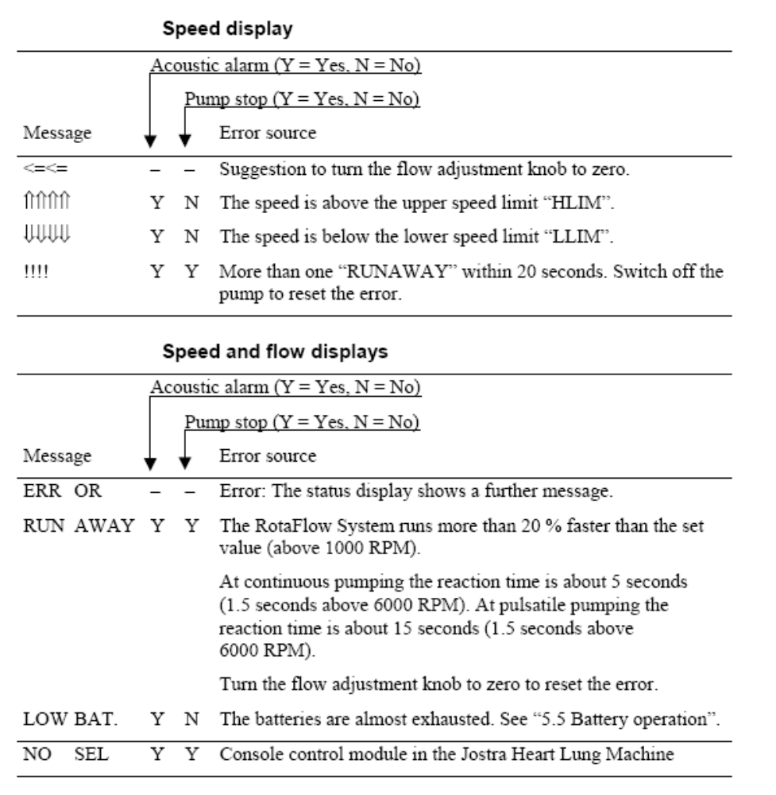
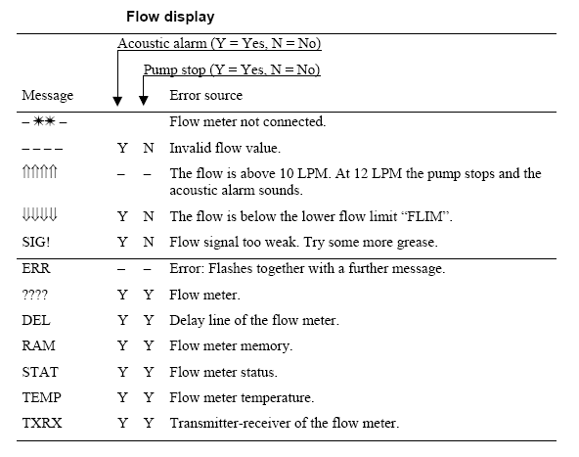

Status display 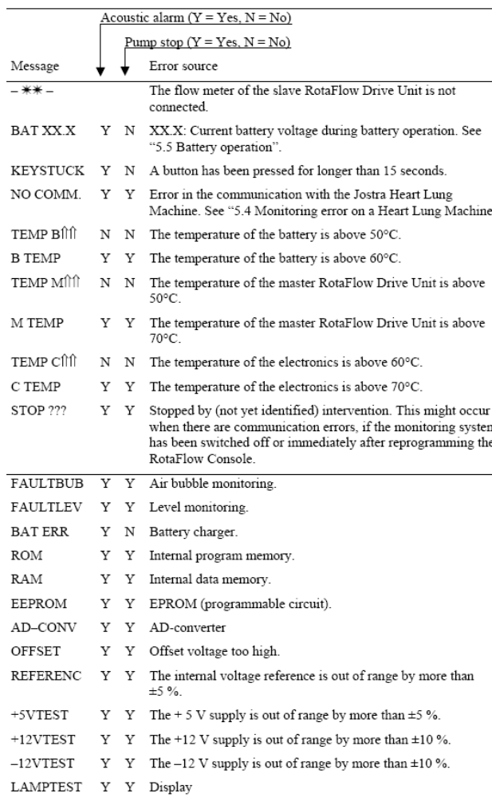
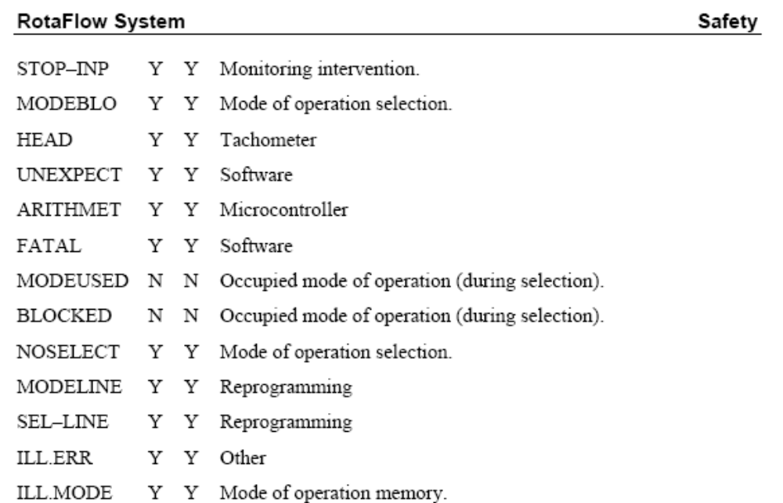

NOTE If the temperature of the electronics in the RotaFlow Console is
above 45°C the ventilator switches to full speed.

If the RotaFlow System stops due to the temperature, it cannot be
started until the temperature has gone down.

The RotaFlow System should not run so hot in normal operation that
a display message is shown. If this happens, contact Jostra Service.

